**ImmunizeVA’s 4th Annual Meeting Agenda**

***Friday, May 2, 2025***

***Lewis Ginter Botanical Gardens, Richmond VA***

**8:30 – 9:00** **Breakfast & Time with Exhibitors**

**9:00 – 9:15** **Welcome**

Denise Kesler Olson

ImmunizeVA Steering Committee Chair

**9:15 – 9:30** **Opening Remarks**

Vanessa Walker Harris, MD

Director, Office of Family Health Services

Virginia Department of Health

**9:30 – 10:30** **Keynote**

Karen Ernst, MA

Voices for Vaccines

Task Force for Global Health

**10:30 – 10:45** **BREAK with Exhibitors**

**10:45 – 11:45** **Working Sessions**

**11:45– 12:30** **Lunch & Awards Ceremony**

**12:30 – 1:15** **Virginia Vaccination Update**

Christy Gray, MPH, CHES, CHTS-CP

Director, Division of Immunizations

Office of Epidemiology

Virginia Department of Health

**1:15 – 2:30** **Collaboration Panel**

Rebecca Brown, PharmD & Cindy Warriner, BS, BSPharm, RPH, CDCES

Patty Slattum, PhD, PharmD & Lindsey Johnson, CPC, BS, THRP

Karen Johnson, Rappahannock-Rapidan Health District & Caitlin Gurten, Culpeper County Public Schools

**2:30 – 2:45** **BREAK with Exhibitors**

**2:45 – 3:45** **Advocacy Panel**

Brent Ewig, MHS

Chief Policy Officer, Association of Immunization Managers

Richard Hughes IV, JD, MPH

Epstein Becker & Green, P.C.

Professorial Lecturer in Law, The George Washington University Law School

**3:45 – 4:00** **Closing**

***A copy of the agenda with learning objectives can be found at https://www.immunizevirginia.org/2025-annual-meeting***

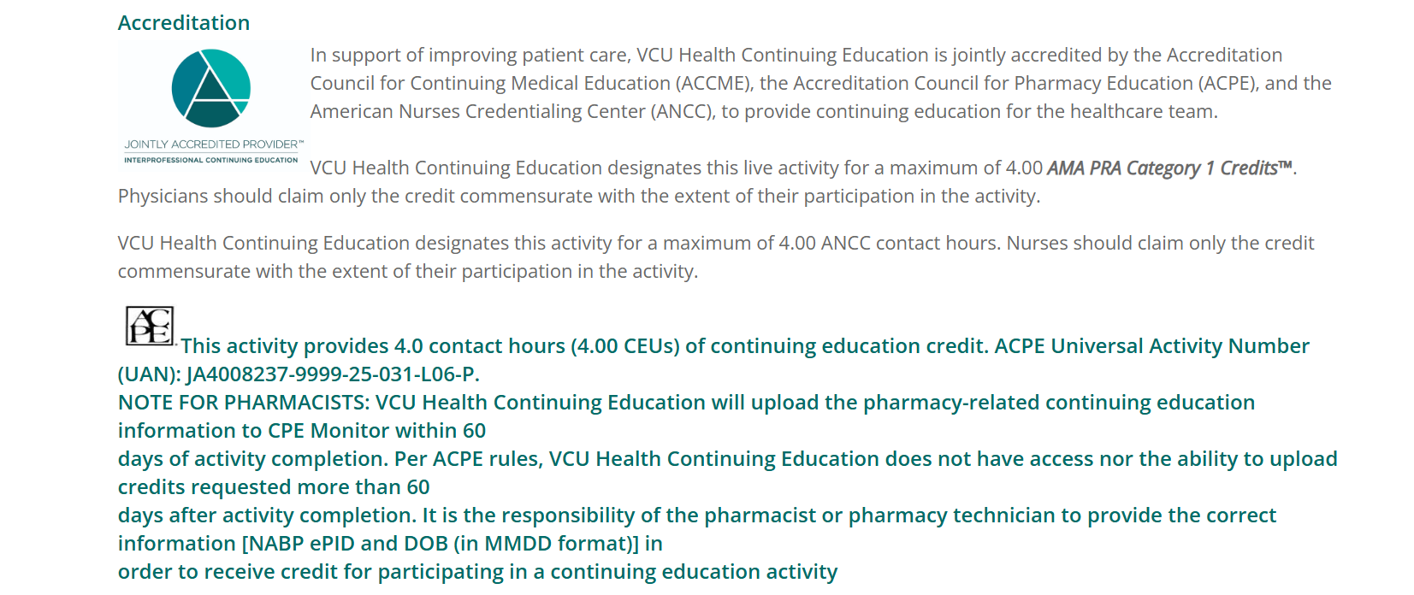

We would greatly appreciate your feedback via this Survey Evaluation QR:

